Lab Setup:
Tools Required:
- VirtualBox or VMware
- Windows ISO file
- A host system (Linux or Windows)
Specifications:
- 4 GB RAM
- 2 Processors
Step 1: Create Host-only network
In Virtualbox:
Open Tools → Network → Click on create →Add host-only Ethernet adapter → Configure adapter manually → Set IP address 192.168.56.1 →DHCP should be unable
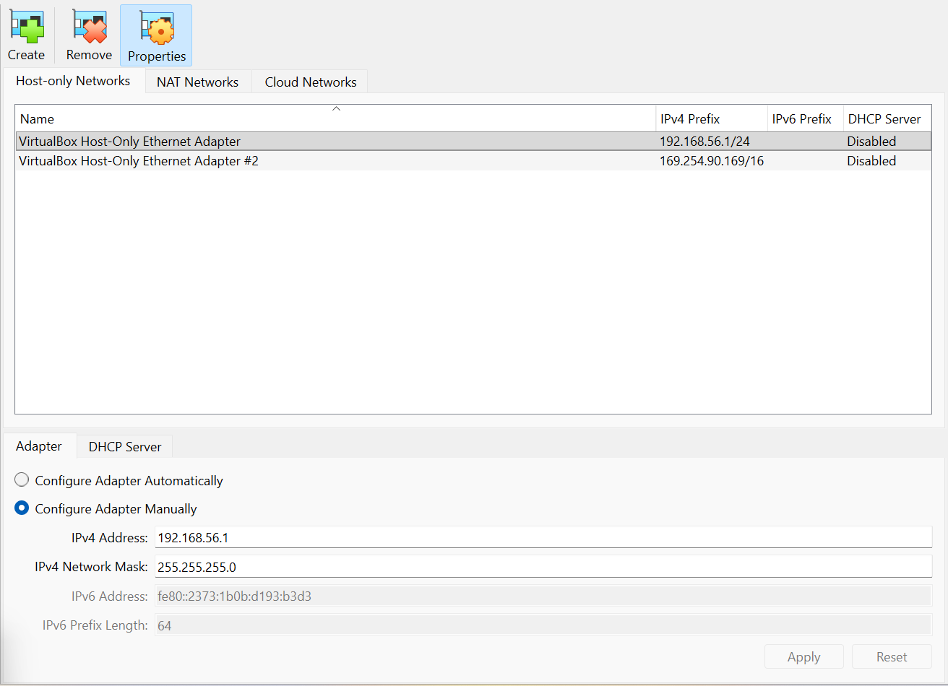
This completely removes internet access.
Step 2: Add the Windows Virtual Machine
Click New VM
Select:
- OS Type: Windows
- RAM: Minimum 4 GB
- CPU: Minimum 2 cores
Attach the Windows ISO
Complete Windows installation normally
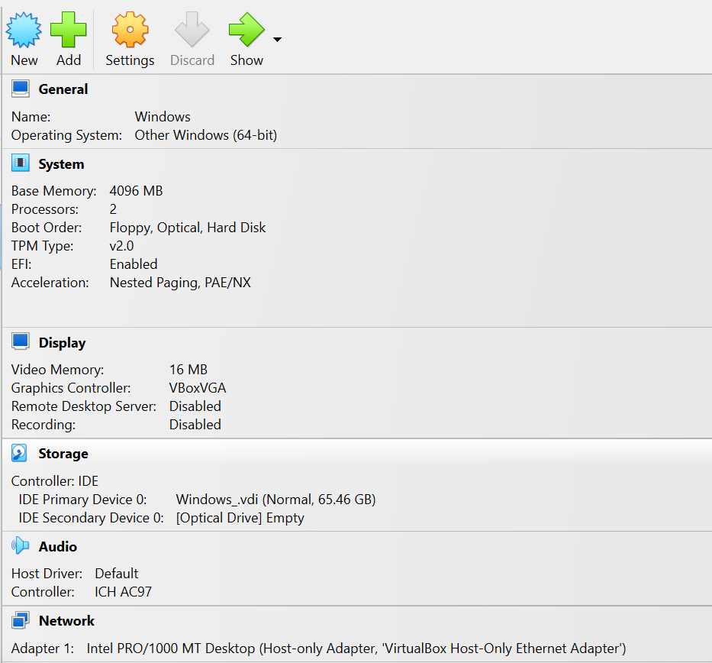
After installation, set adapter to host only
Step 3: Configure Kali IP manually
For a safe and reliable home lab environment, it is essential to assign static IP address to kali.
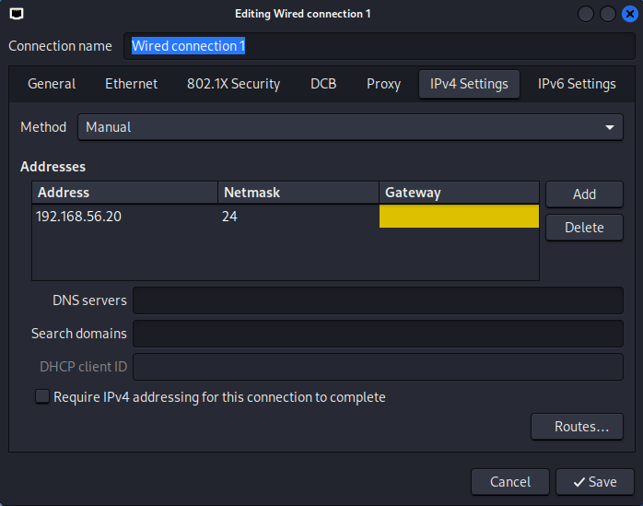

Check if IP successfully assign to kali:
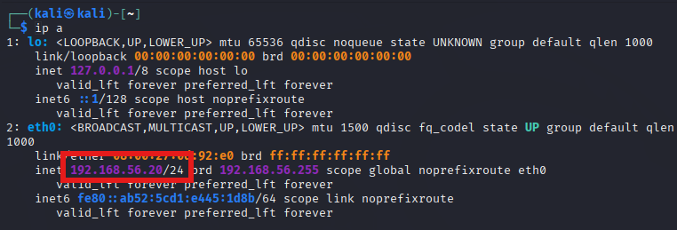
Step 4: Configure Windows IP manually
For a safe and reliable home lab environment, it is essential to assign static IP address to windows.
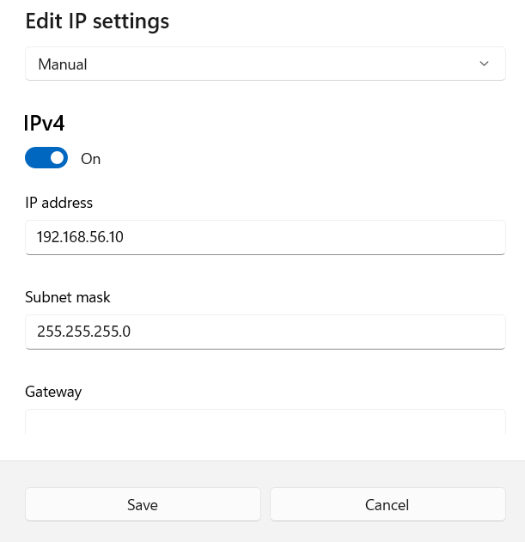
Check if IP successfully assign to windows:
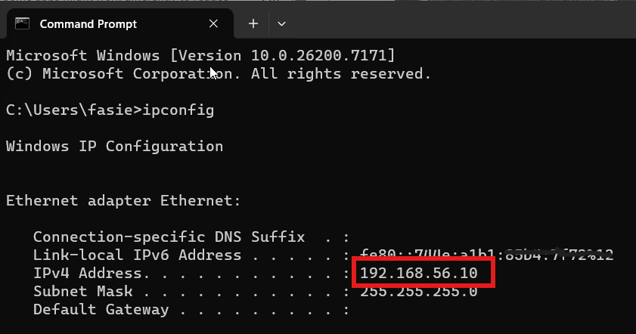

Step 5: Verify isolating using ping
Kali(attacker machine) successfully ping windows.
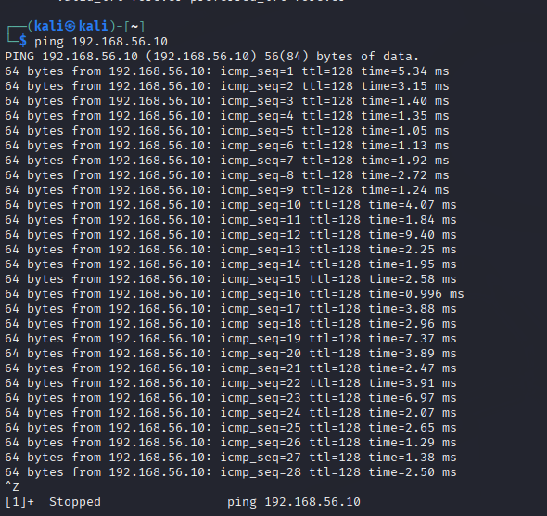
Check if it blocks internet access:
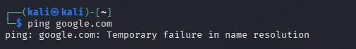

Windows (target machine) successfully ping kali.
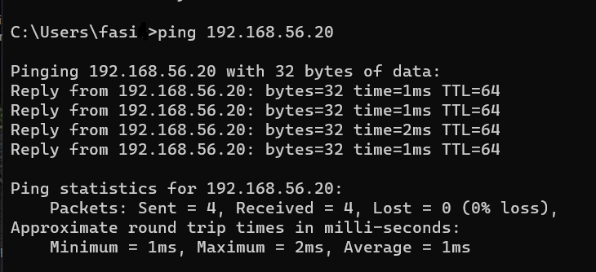

Check if it blocks internet access:
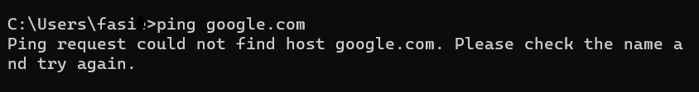

Conclusion:
Finally, built a safe, fully isolated hacking lab where attacks, malware, and exploits cannot escape to the real internet.

